Project 2 Planning Document

Movey – Sports Community app

By Rareș Nagy

Table of Contents

Introduction 3

Timetable 3

Design 3

Goals 4

Entity–Relationship Diagram (ERD) 4

Backend 4

Realisation 4

Backend and Database 4

Goal 4

Frontend 4

# Introduction

This document shows a rough plan of how I’m going to develop my second project. It includes a timetable and objectives for each stage of development.

# Timetable

I’ve arranged everything I need to do within my 4 weeks. First, I need to analyze the problem which should take around 2 days, then I need to make choices regarding the technology, that can be done in a single day. The project’s design comes after that, It will take half a week to do it. And then the realization, which I’ve allocated 2 weeks to. After the last week, validation, the project is complete.

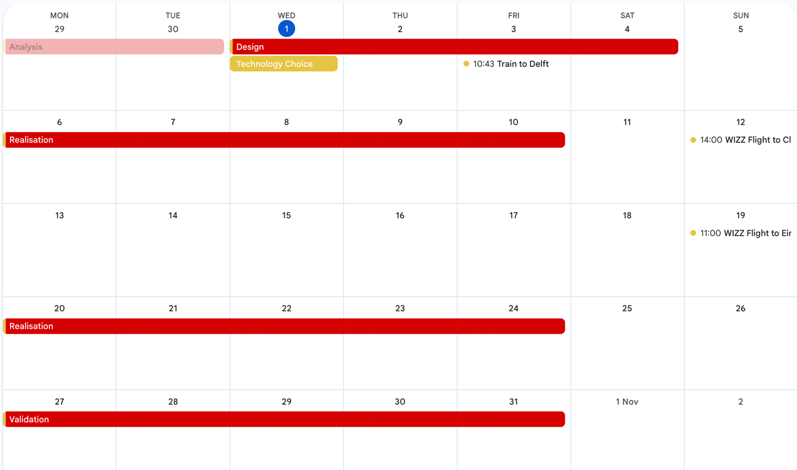As the realization will take most of the 4 weeks, it makes sense to split it in different stages and have different goals for it

# Design

Having a good design will help a lot in managing my time with the other stages. Getting it done as early as possible is crucial for good time management.

## Goals

### **Entity–Relationship Diagram (ERD)**

By the end of the design phase I should already have my database’s relations mapped out. This will make implementing these a lot easier in the realization stage.

### Backend

A table of all the endpoints that includes the method used, the path to the endpoint, a list of the requested body and maybe a response will need to exist before the backend is implemented.

### Frontend (Help me here)

# Realization

## Backend and Database

After the design is done, creating the API endpoints should be easy to do without having the frontend. I will allocate half the realization’s time to that.

### Goal

By the end of the week all the API endpoints will be functional

## Frontend

After the backend is done, all that is left is for the frontend to take form.